JAVA IO streams

1. Java.io package
2. Io streams are also called file handling or file input output.
3. Main advantage of learning this api is to store data into a file permanently and retrieve data from the file.
4. We have some predefine classes in io stream api to store the data and retrieve the data.
5. And we can also read values from key board and display to console.

* System.in
* System.out
* System.err

Where to use I/O streams?

1. If we want to store small amount of data with out security then we can use i/o stream concept. If we want to store large amount of data with security then we need to store in database.

What is a stream?

A stream is a logical connection between java application and to file through which I can write data into file and I can read data from file to java program.

There are two types of streams

1. Output stream

We can send data from program to file.

1. Input stream

We can retrieve data from file to program.

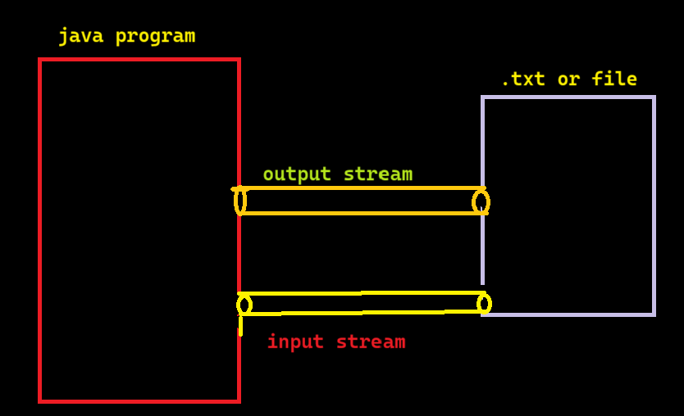

How many ways we can send/ retrieve data from both output stream and input stream?

We can send or retrieve data in two types

1. Binary data (0’s and 1’s) which we can call binary stream.
2. Char data 🡪 which we can call char stream.

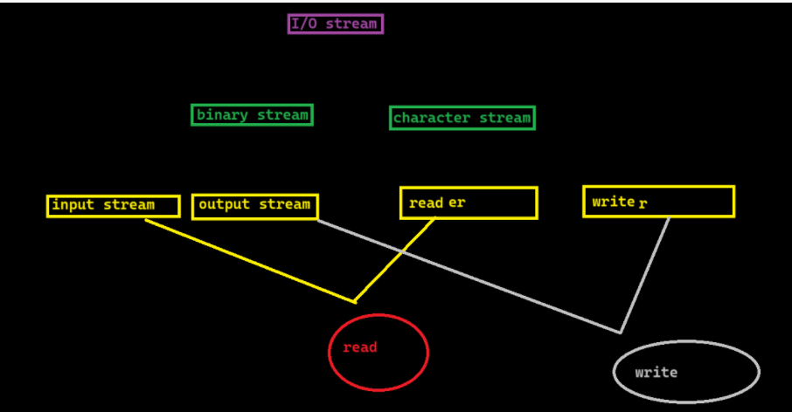

Understand about I/O classes?

1. Input stream class and output stream class are abstract classes having some pre define methods.
2. But in input stream there is abstract method called read () and in output stream there is abstract method called write ().
3. We need to implement logic for methods based on destination files.

Classes available in input stream?

Input stream (super class)

================================================

Sub classes

* File input stream
* Byte array input stream
* Filter input stream

\*Data input stream

\*Buffered input stream

* Object input stream
* Piped input stream
* Sequency input stream
* String buffer input stream

Classes available in output stream?

* + - Output stream (super class)
* =========================================
  + - Sub classes
* File output stream
* Byte array output stream
* Filter output stream
  + \*Data output stream
  + \*Buffered output stream
  + \*print stream
* object output stream
* piped output stream

1. Fis. Read ();

It read only single byte and displays in int format. To display in character, we need to do type casting.

If file is not there it will throw FNFE.

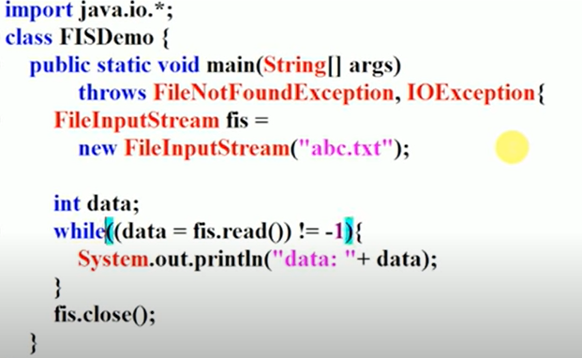

In while loop we selected -1 because, in file if no data is present then the output will be -1.

Then it says that there is no data in file and print the output and exist the loop.

1. Fos. Write ()

If file is not present in system it will create the file and it will save the data into file. It won’t through any exception.

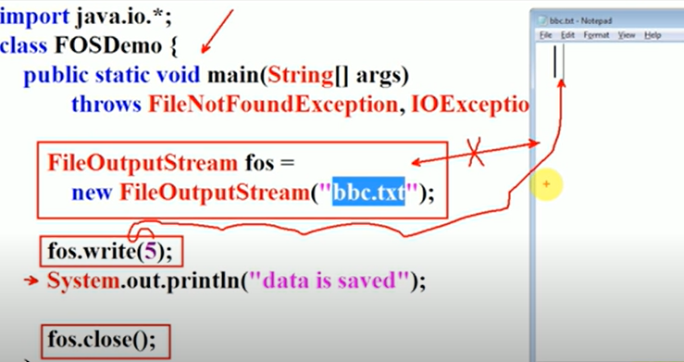

File copy operation

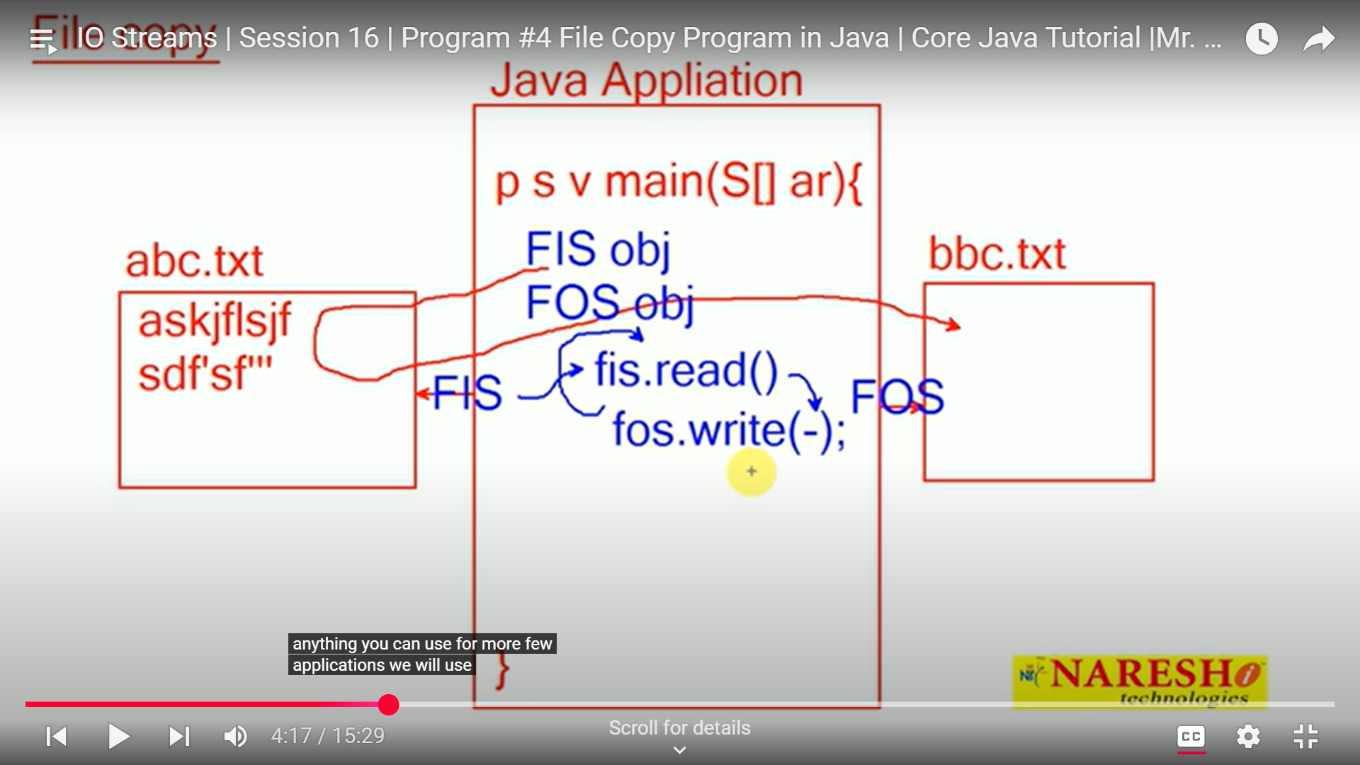

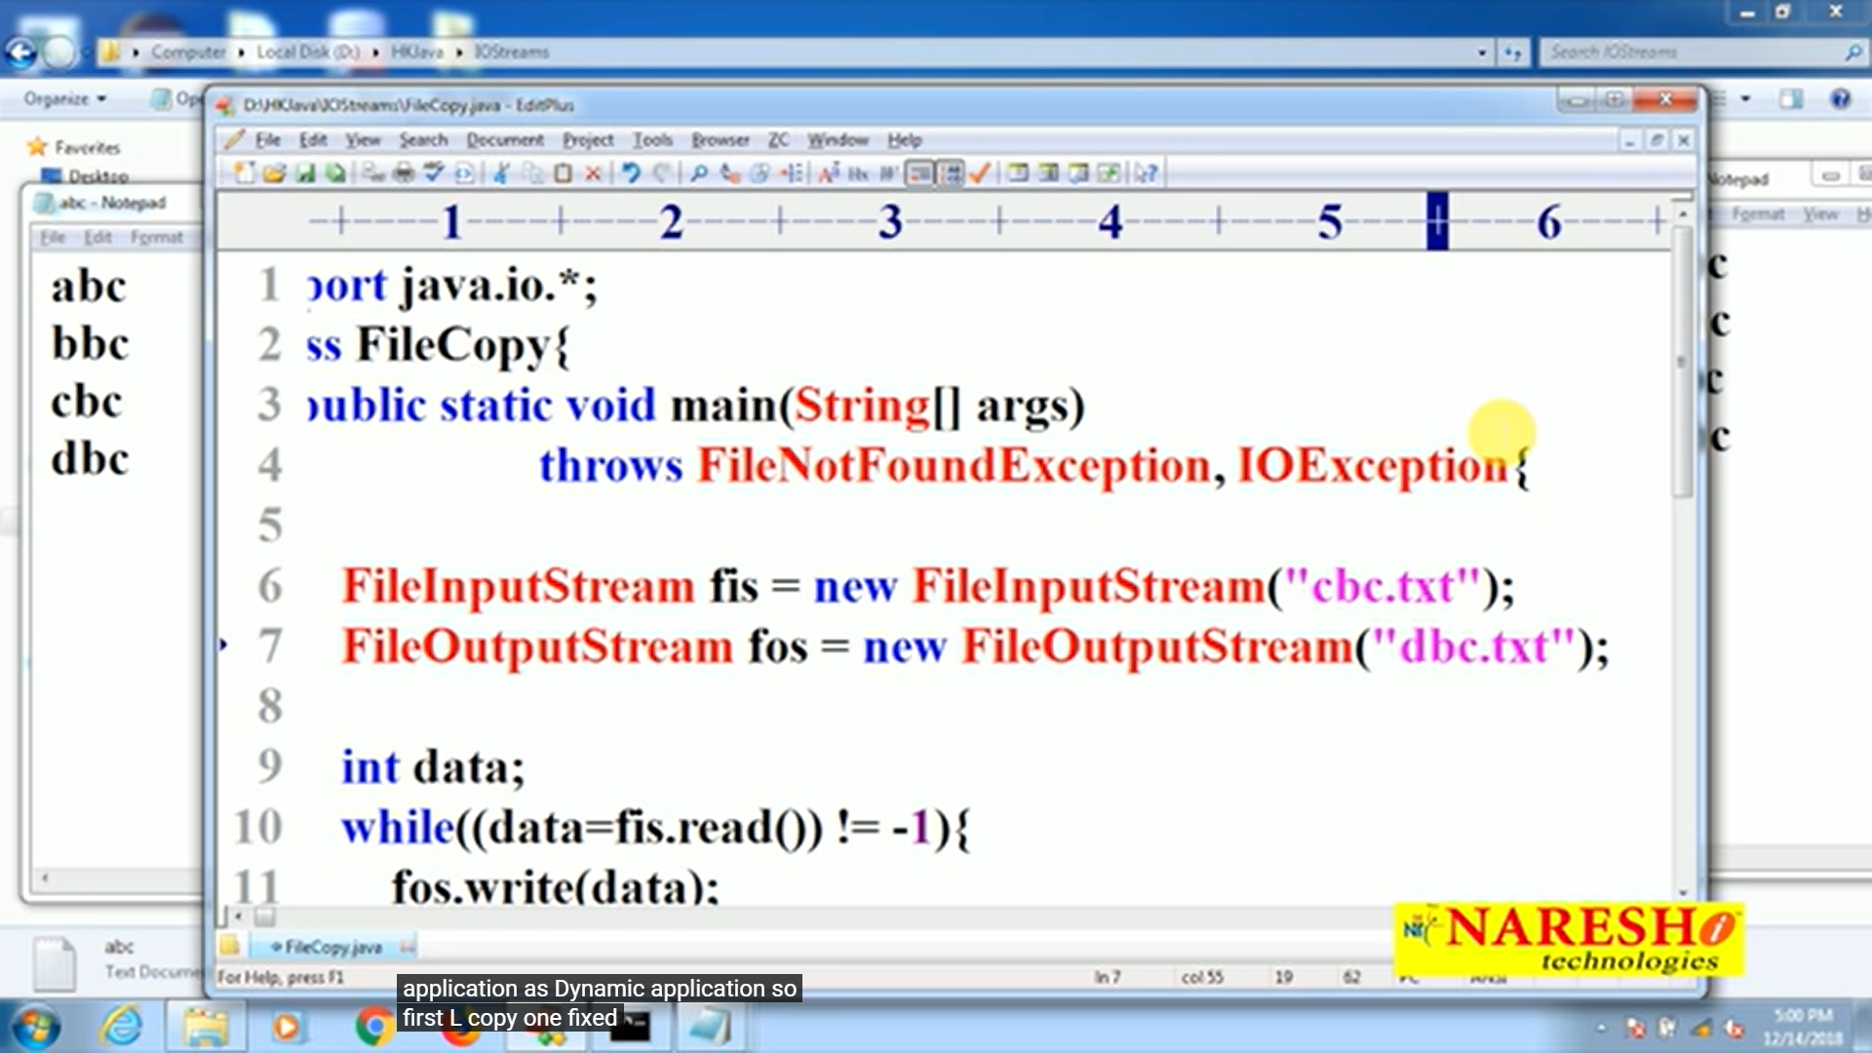

File copy dynamically

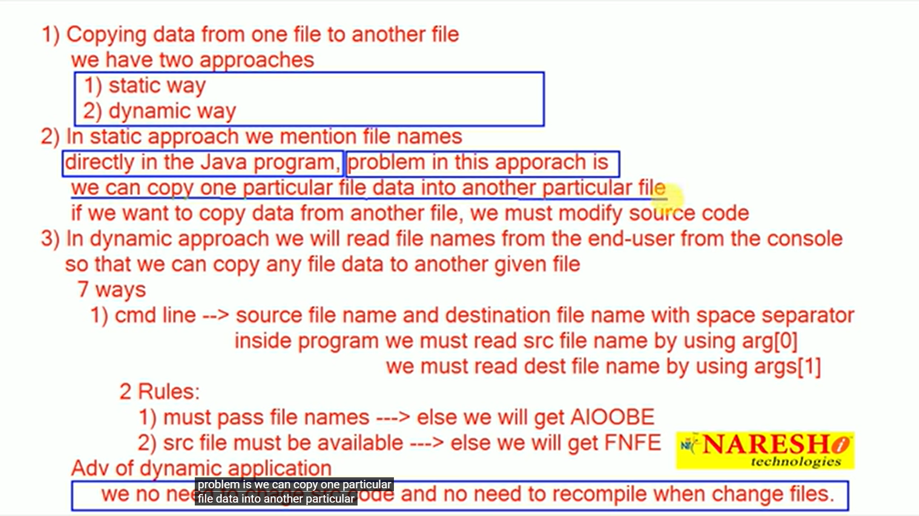

Pasing files name via console

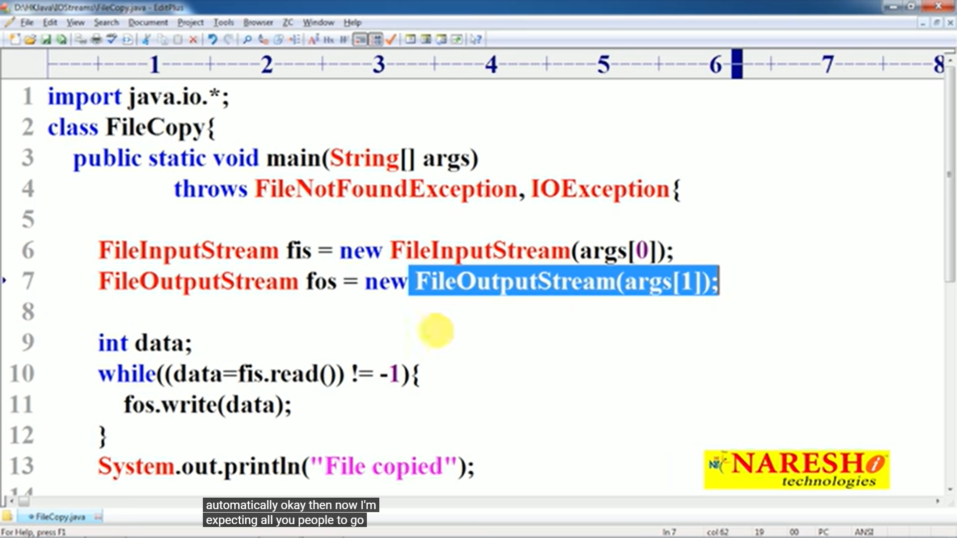

Passing files via Command line arguments

